
2” Lift System for 1999 and newer
Ford F-250 / 350 Super Duty 4WD Pickup

INSTALLATION INSTRUCTIONS

INTRODUCTION
Installation requires a professional mechanic. Prior to beginning, check all suspension-to-frame attaching points for stress cracks. The overall vehicle must be in excellent working condition; repair or replace all worn parts.

Read instructions several times before starting. Be sure you have all needed parts and know where they install. Read each step completely as you go.

NOTES:
- Ford made a mid-year production change to the front U-bolts in 1999. Vehicles with a production date prior 2-28-99 utilize square front U-bolts, while vehicles manufactured on or after 3-1-99 may utilize square U-bolts or large-radius U-bolts. Kit box #9625 includes the square U-bolts, while kit box #9626 includes both U-bolt styles. Verify the correct front U-bolts are supplied prior to beginning installation.
- The rear lift is sold separately and includes separate installation instructions.
- Save all factory mounting hardware for reuse, unless otherwise noted.
- A factory service manual must be on hand. The manual will contain fastener torque specifications, assembly techniques, and / or special tool requirements that are unique to this particular year and model vehicle.
- Do not add or fabricate any components to gain additional suspension height.
- Prior to attaching components, be sure all surfaces are free of grit, grease, undercoating, etc.
- A torque specification in foot-pounds is shown in parenthesis “( )” after each fastener.
- Use the check off box “” found at each step to help you keep your place. Two “” denotes that one box is for the driver side and one is for the passenger side.
PARTS LIST … The part number is stamped into each part or printed on an adhesive label. Identify each part and place the appropriate mounting hardware with it.
PART NO DESCRIPTION NEW ATTACHING HARDWARE
(Qty.- if more than one) (Qty.- if more than one)
01-221-6 (2) front spring

gas engine

OR

01-222-6 (2) front spring
V-10, diesel engine

55-04-9620 front track bar bracket (1) 5/8” x 3-1/2” bolt

models made on or (1) 5/8” nyloc nut
before 2-28-99

OR

55-04-9622 front track bar bracket
models made on or after 3-1-99

10622 (4) square U-bolt (8) 9/16” nyloc nut

most models made on or (8) 9/16” extra-thick flat washer
before 2-28-99 (see notes)

OR

10902 (4) large radius U-bolt (8) 9/16” nyloc nut
most models made on or (8) 9/16” extra-thick flat washer
after 3-1-99 (see notes)

85144 (650328) (2) shock absorber, front (2) shock boot*, tie, decal
(2) hardware pack
85158 (650341) (2) shock absorber, rear (2) shock boot*, tie, decal
(2) hardware pack
*(Note: Shock boots, if desired, purchased seperately)
00461 decal, “Warning To Driver”
00421 decal, 2” x 5” yellow Superlift

INSTALLATION PROCEDURE

1) PREPARE VEHICLE...
❑ Place vehicle in neutral. Raise front of vehicle and secure a jack stand beneath each frame rail, behind the front spring shackles. Ease the frame down onto the jack stands. Leave the jack under the axle to support it while the suspension is disassembled. Place transmission in low gear or “park”, and chock rear tires. Remove front tires.

2) REMOVE FRONT BUMPER...
❑ Using a clip tool or a large flat head screwdriver, disconnect the rubber splash panel from beneath the front bumper. Disconnect the block heater plug “Christmas tree” clip from the bumper (if so equipped).

❑ Remove the four bumper-to-frame bolts and lay the bumper aside.

3) CONTINUE DISASSEMBLY...
❑ The track bar’s lower end attaches to the passenger side of the front axle. It’s upper end mounts to a bracket that ties into the passenger side frame rail and the primary frame crossmember. Disconnect the track bar from it’s upper mounting bracket and let the bar hang. Now unbolt the bar’s upper end mounting bracket.

 Remove the factory shock absorbers.

 On each side, a rubber compression travel stop is bolted to the bottom of the frame rail, just inboard of the shock absorbers. Remove the stops and save the hardware for reuse.

4) FRONT LEAF SPRING REMOVAL...
Leaf spring removal and installation (steps 4 and 5) is performed one side at a time. Start with the driver side.

 Position the floor jack under the driver side knuckle. Load the jack so that it supports, not raises, the axle; the frame rail is to remain securely on the jack stand.

 Remove the two spring-to-axle U-bolts. Now remove the top U-bolt / shock plate and the bottom U-bolt cradle.

 Remove the spring shackle bolt and swing the shackle back and away from the spring.

 Unbolt the spring’s front eye from it’s hanger, then lower the jack enough to allow spring removal.

5) SUPERLIFT SPRINGS...
 Position the spring so that the eye with the large bolt hole is pointed toward the front of the vehicle. It is easiest to insert the Superlift spring from front of vehicle. Position the spring eye in the front hanger and install the factory bolt from the inside, facing outward. Install factory retaining nut and hand tighten only. The bolt is fully tightened in a later step when the suspension is supporting vehicle weight.

 Position the spring onto the axle. Raise the jack and mate the rear spring eye to the shackle. Insert factory bolt from the inside, facing outward. Install factory nut and hand tighten only.

 Position top U-bolt plate, and bottom U-bolt cradle, and install U-bolts. Snug-up, do not fully tighten U-bolts. As with the spring eye bolts, they are fully tightened later.

❑ Repeat steps 4 and 5 on passenger side.

6) DRILLING THE TRACK BAR…

NOTE: THIS STEP IS ONLY PERFORMED ON MODELS MADE ON OR BEFORE 2-28-99. IF THE VEHICLE WAS MADE ON OR AFTER 3-1-99, PROCEED TO STEP 7.

❑ Note the upper and lower ends of the track bar (it must be installed in the same position it was removed). Unbolt the track bar from its lower mounting point on the axle.

❑ Place the track bar in a vise or other suitable fixture.

❑ Using a 5/8” bit, drill out the center of the sleeve pressed into the upper end of the track bar. Take precautions to ensure the bit doesn’t bind in the sleeve and clean up any burrs with a hand file.

❑ Reinstall the lower end of the track bar on the axle using the factory fastener and tighten to factory specifications.

NOTE: While the factory hardware and sleeve will fit the Superlift bracket, failure to perfrom step 6 will result in an intermitent “popping” noise, especially while turning, due to excessive clearance between the factory bolt and sleeve.

7) TRACK BAR BRACKET #55-04-9620 OR #55-04-9622...
- Install the new Superlift “04” track bar bracket into the original bracket location. Reuse the factory fasteners (130).

❑ If using #55-04-9620 (vehicles made on or prior to 2/28/99), attach the upper end of the track bar to the “04” bracket using the supplied 5/8” x 3-1/2” bolt and 5/8” nyloc nut. Insert the bolt from front to rear. Hand tighten only; the bolt is fully tightened in a later step.

❑ If using #55-04-9622 (vehicles made on or after 3/1/99), attach the upper end of the track bar to the “04” bracket using the factory bolt. Insert the bolt from front to rear. Hand tighten only; the bolt will be fully tightened in a later step.

8) SUPERLIFT FRONT SHOCK ABSORBERS #85144...
 Install the shock bushings, boot, and decal.

 Install the shock. Tighten the upper nut (76) and lower bolt (76).

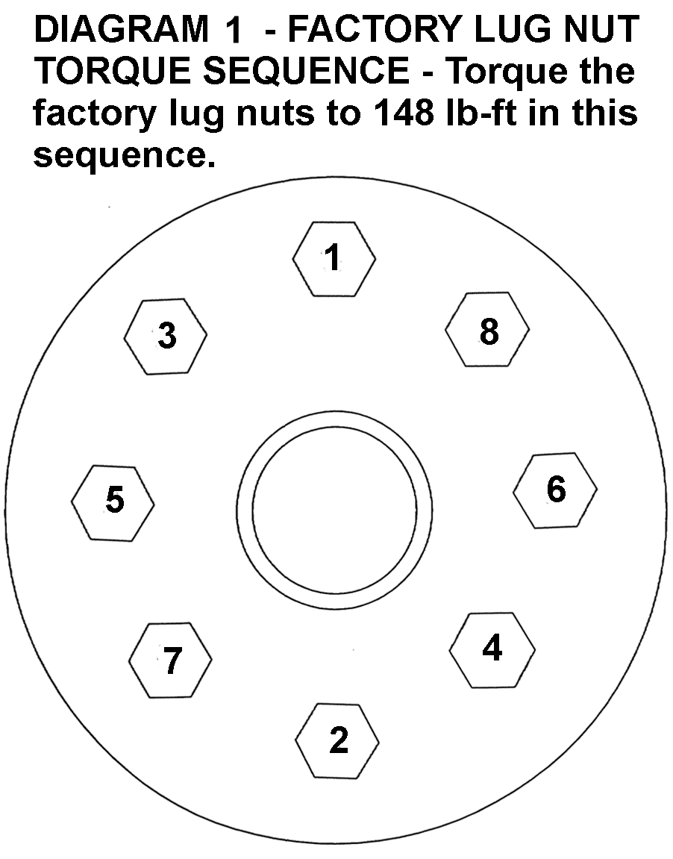
9) WHEELS / TIRES...
WARNING: When a wheel is installed, always check for and remove any corrosion, dirt or foreign material on the mounting surfaces of the wheel, or the drum / rotor surfaces that contact the wheel. Installing wheels without proper metal-to-metal contact at the wheel mounting surfaces can cause the lug nuts to loosen and the wheel to come off while the vehicle is in motion.

NOTE: Inspect the lug nut and washer assemblies. Replace the assembly if the washer portion will not spin freely.

 Position wheel / tire onto vehicle. Turn the wheel until one lug is at the top of the wheel hub bolt circle.

 Install the lug nuts loosely. Use the lug nut tightening pattern shown in [DIAGRAM 1] to tighten the remaining lug nuts to minimize runout. Tighten the lug nuts only until snug. The lug nuts are fully tightened in a later step.

10) INITIAL CLEARANCE CHECK...
 With the vehicle still on jack stands, lower the jack(s) so the suspension is “hanging” at full extension travel. Cycle the steering lock-to-lock and check all components for proper operation and clearances.

11) TORQUE SPECIFICATIONS and FINAL CLEARANCE CHECK...
❑ Raise vehicle and remove jack stands. Lower the vehicle to the ground so that the suspension is supporting the weight of the vehicle. Torque the following:

 1) front leaf springs, rear (shackle) eye (185)
 2) front leaf springs, front eye (259)
❑ 3) track bar eye bolt, upper end (129)
 4) [DIAGRAM 1] wheel lug nuts (148)

CAUTION: Failure to tighten the lug nuts in the sequence shown can result in high tire and wheel runout, which speeds up the development of brake roughness, shudder and vibration.

WARNING: Retighten lugs at 500 miles after any wheel change, or anytime the lug nuts are loosened. Failure to do so could cause wheels to come off while vehicle is in motion.

❑ Again cycle the steering lock-to-lock and inspect the tires / wheels, and the steering, suspension and brake systems for proper operation, tightness and adequate clearances.

12) REAR LIFT...
Superlift’s rear block lift includes it’s own generic installation instructions. To eliminate any possible confusion, we are verifying here that the Superlift lift blocks seat against the axle, and the factory spacers are placed on top of the Superlift blocks. Torque specification for the Superlift 5/8” diameter U-bolts and Nyloc nuts is (185).

13) SUPERLIFT REAR SHOCK ABSORBERS #85158...
 Remove the factory shock absorber.

 The lower end of the shock is attached to a bracket, which in turn, attaches to the axle tube via a U-bolt. To shorten the required shock length, loosen the U-bolt and rotate the shock attachment point up. There is a bracket locating button on the axle tube; the bracket / U-bolt assembly will rotate up until the U-bolt makes contact with the button. Evenly tighten the U-bolt nuts: Ford axle (35), Dana axle (46).

 Install the shock bushings, boot and decal. Install the shock. Tighten both shock eye mounts (46).

14) HEADLIGHTS...
❑ Readjust headlights to proper setting.

15) SUPERLIFT WARNING DECAL...
❑ Install the “WARNING TO DRIVER” decal on the inside of the windshield, or on the dash, within driver’s view. Refer to the “NOTICE TO DEALER AND VEHICLE OWNER” section below.

IMPORTANT PRODUCT USE INFORMATION
As a general rule, the taller a vehicle is, the easier it will roll over. Offset, as much as possible, what is lost in roll over resistance by increasing tire track width. In other words, go “wide” as you go “tall”. Many sportsmen remove their mud tires after winter / hunting season and install ones more appropriate for street driving; always use as wide a tire and wheel combination as possible to enhance vehicle stability.
We strongly recommend, because of roll over possibility, that the vehicle be equipped with a functional roll bar and cage system. Seat belts and shoulder harnesses should be worn at all times. Avoid situations where a side rollover may occur.

Generally, braking performances and capabilities are decreased when significantly larger / heavier tires and wheels are used. Take this into consideration while driving.

Do not add, alter, or fabricate any factory or aftermarket parts to increase vehicle height over the intended height of the Superlift product purchased. Mixing component brands is not recommended.

Most states have some type of law limiting vehicle height. The amount of lift allowed, and how the lift may be achieved, varies greatly. Several states offer exemptions for farm or commercially registered vehicles. It is the owner’s responsibility to check state and local laws to ensure that their vehicle will be in compliance.

Superlift makes no claims regarding lifting devices and excludes any and all implied claims. Superlift will not be responsible for any altered product or any improper installation or use of our products.
We will be happy to answer any questions concerning the design, function, and correct use of our products.

IMPORTANT MAINTENANCE INFORMATION
It is the ultimate buyer’s responsibility to have all bolts / nuts checked for tightness after the first 100 miles and then every 1000 miles. The steering, suspension and driveline systems, along with wheel alignment should be inspected by a qualified professional mechanic at least every 3000 miles.

NOTICE TO DEALER AND VEHICLE OWNER
Any vehicle equipped with a Superlift lifting device must have the enclosed “Warning to Driver” decal installed on the inside of the windshield or on the vehicle’s dash, within driver’s view. The “Warning to Driver” decal is to act as a constant safety reminder for whoever may be operating the vehicle. The WARRANTY IS VOID unless this decal is in place. INSTALLING DEALER... It is your responsibility to install warning decal and forward these installation instructions to the vehicle owner for review of warnings, product use and maintenance information. Replacement warning decals are available free upon request. These instructions are to be kept with the vehicle registration papers and owners manual for the service life of the vehicle.

SUPERLIFT LIMITED LIFETIME WARRANTY
Suspension products bearing the Superlift (LKI Ent.) name are warranted for as long as the original purchaser owns the vehicle that the LKI product was originally installed on. This warranty is non-transferable. Warranty covers only the product, no labor, time loss, or freight incurred. Any product that has been abused, altered, incorrectly installed, or used in competition is not covered. Product finish, spring bushings, Polyurethane products, and normal wear is not covered. The LKI product is subject to replacement or repair. No other warranties are expressed or implied. An authorized Superlift dealer must inspect the part in question and confirm that the “Warning to Driver” decal is properly displayed. A copy of the sales invoice is required for warranty consideration.

SUPERLIFT SUSPENSION SYSTEMS
300 Huey Lenard Loop Rd.
West Monroe, Louisiana 71292-9421
Phone: (318) 397-3000
Sales / Tech: 1-800-551-4955
FAX: (318) 397-3040

Web Site: www.superlift.com

